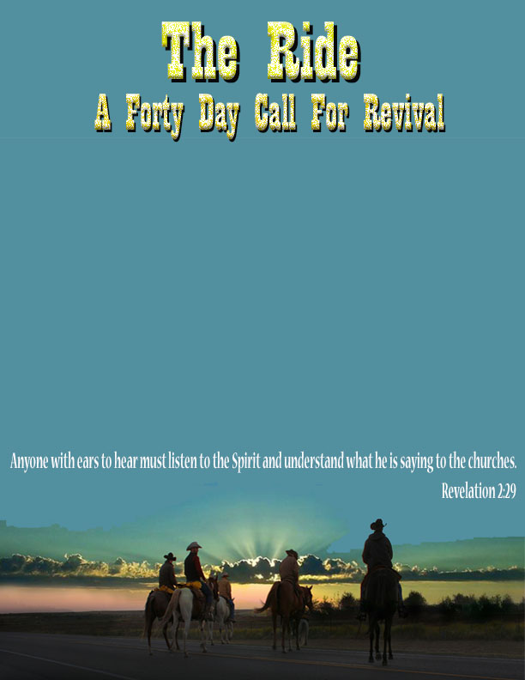

**CITY:**

**LOCATION:**

**DATE: TIME:**

Texoma Cowboy Church www.texomacowboychurch.com

Wichita Falls, Texas 940-687-2237

Everyone is invited